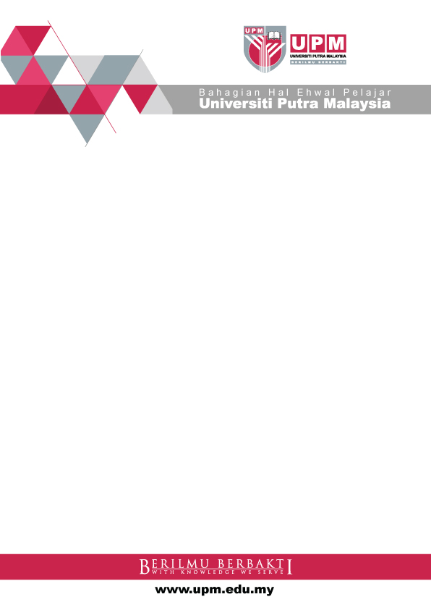

**INDUSTRIAL TRAINING PROGRAMME**

**Eligibility Requirements**

* CGPA of at least 3.0 and above
* Achieved a minimum requirement of MUET Band 3

This Industrial Training Programme is opened to Degree Students in

**Business Management / Finance / Human Resource / Accounting / Information Technology / Computer Science.**

*Industrial Training allowance will be provided.

Location : 9th Floor Wisma Sime Darby

Jalan Raja Laut, 50350 Kuala Lumpur.

Telephone : 03-2718 2600 Ext: 81001617 / 81001447 / 81001620.

Fax : 03-27110638

Any students who would like to join, please email to [athirah.tanda@simedarby.com](mailto:athirah.tanda@simedarby.com) / [norhayati.isin@simedarby.com](mailto:norhayati.isin@simedarby.com)

**SIME DARBY GLOBAL SERVICES CENTRE SDN. BHD.**